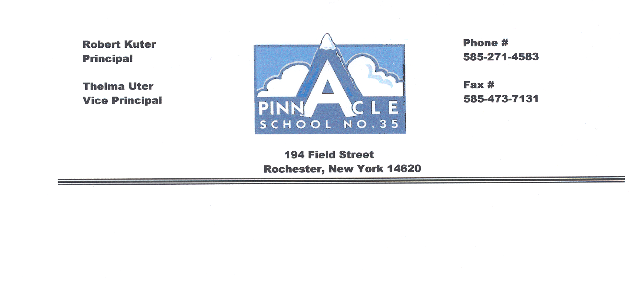
Pinnacle School #35
(Use this form as a checklist, check and date boxes for your records)
Academic Intervention Process
Student is demonstrating difficulty in class.

Look At Tier I
- Common Core Instruction with fidelity for all students
Student success – Continue Tier I Intervention.

- Differentiation Strategies being used
- Present student to grade level for suggestions/ideas for differentiation
- Meet with Instructional Coach

Student continues demonstrating difficulty in class and/or is below on Universal Screening.

Move to Tier II  Actions:  - Send out Parent Notification Intervention Letter  - Meet with grade level team to create a strategic Tier II Intervention  - Review student’s cum for previous Interventions tried  - Notify parents of concerns and your actions  - Review data at monthly GLT Data Review (every 4 wks.) | Tier II (4-6 wks.)  - Strategic Interventions  - Researched based in addition to the core curriculum  - Small group instruction(5-9 students) 3 times a week for 20-30 minutes  - Targeted to skill deficits  - Progress monitoring two times a month (every other week)
Student continues demonstrating difficulty try another or change Tier II intervention for another 4-6 weeks of data.
Student success – Continue Tier II
intervention.

Move to Tier III  Actions:  - Fill out Intervention Referral Form  - Read student cum  - Organize student information, intervention, work samples (folder, binder, file)  - Meet with Intervention Team every week | Tier III (4-6 wks.)  - Intensive Interventions in addition to the core curriculum  - Increase time or intensity (every day for minimum 30-60 mins.) in addition to core  - Small grouping (1-5 students)  - Individualized intervention designed by Intervention Team and Classroom Teacher  - *Weekly progress monitoring*
Student continues demonstrating difficulty; Intervention Team will try another or change Tier III intervention for another 4-6 weeks of data.
GLT- Grade Level Team

Student success – Continue Tier III
intervention.

